Trading Chart Pattern Analysis

Team name :- Throne heir

Team member :-

Group member:  
1)Akshay Tarapara (20BCE009)  
2)Brij Sojitra(20BCE035)  
3)Manav Majithiya (20BCE144)  
4)Krishil Rana (20BCE136)  
5)Jenil Kukadiya (20BCE137)

Understanding problem statement: -

You will be given sample time series data and corresponding annotation that denotes where and which pattern exists (in the given data) to train the algorithm and to visualize the data / patterns. Your job is to identify such patterns in the test data.

There are given a four patterns.

1. Double Top

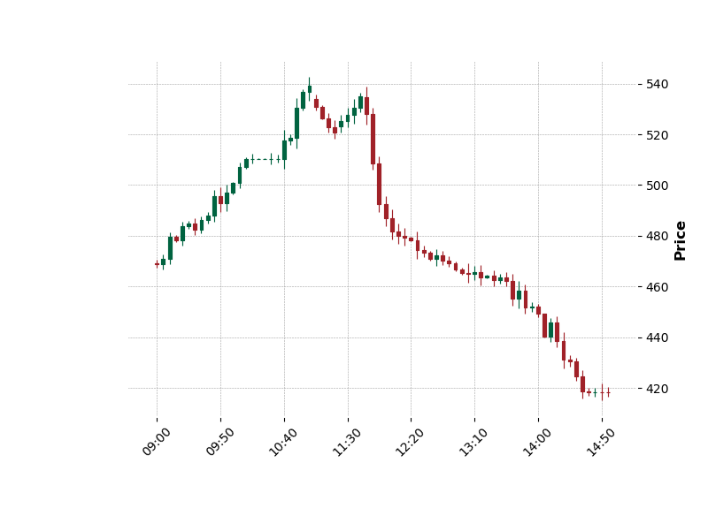

1. Double Bottom

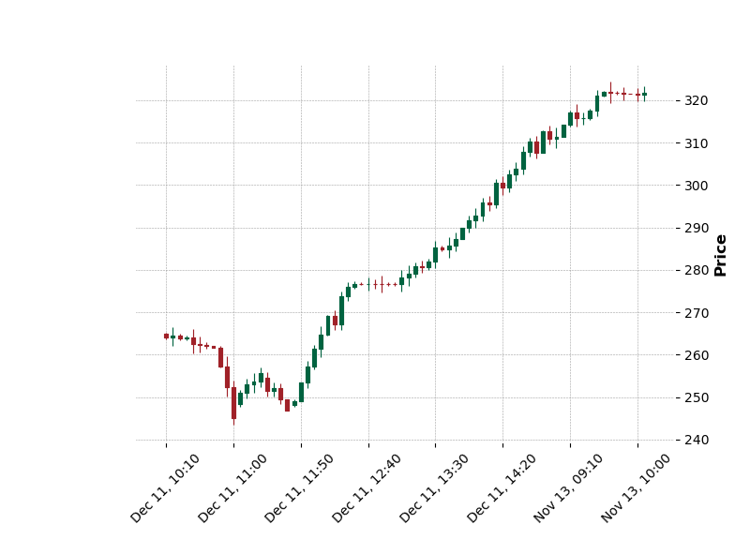

1. Head and shoulders

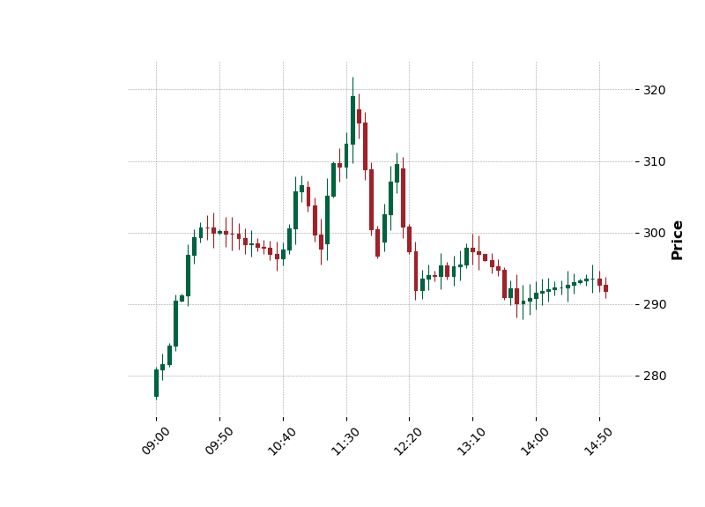

1. Reverse Head and shoulders

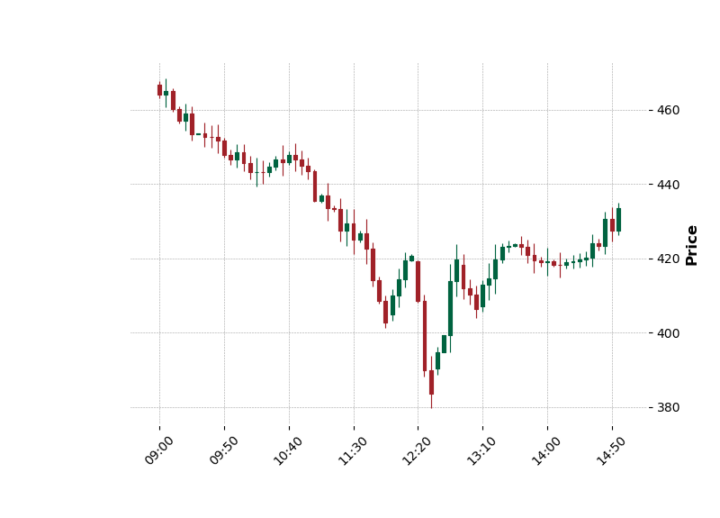

1. NAN (when none of the above pattern matched)

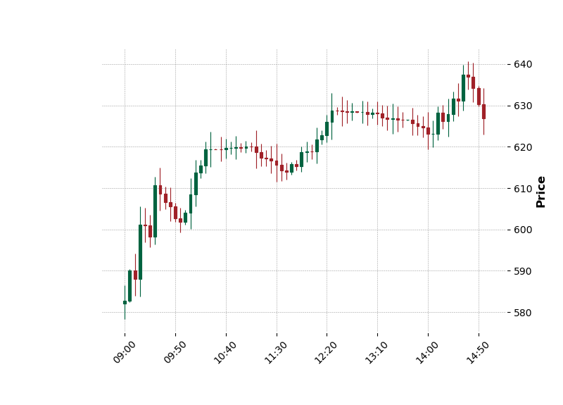

Implementation logic: -

First we have taken the sample data and plotted sample data in the graph. Then we labed each and every graph using sample ground truth data file and we stored it the graph images in the local machine according to their patterns. Then we will take data from testdata file and then plot that data into the graph. Then using image similarity algorithm we find the similarity between test image and each and every sample image of different patterns. Then we store similarity score into the list and find the average similarity of that particular pattern with the test image. We repeated this for a single test image with all the five different patterns. We label the test image with the pattern having the highest similarity.

Input required: -

It basically require CSV file with stock market data represented as Candlesticks of 5 minute intervals. The columns are as follows:

● date: date column comprise of date and time at that point

(Below 5 columns represent the value for each 5 minute intervals)

● open: Starting price of stock

● high: Maximum price (within the given 5 min window)

● low: Minimum price (within the given 5 min window)

● close: Closing Price of stock

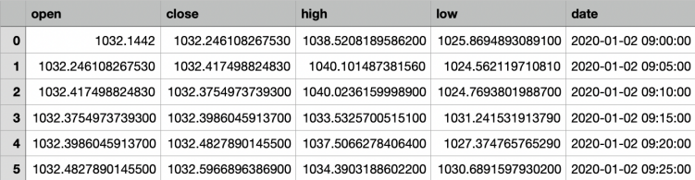

Output: -

In output a csv file which will contain two columns which are as follows:

Date:it’ll represent a input date

Predicted_patteren:It’ll give the predicted pattern for the given date.

How does code work?

Basic logic:we have use image comparision for finding the patterns in the given test data.

First we train the model

Example: -

INPUT :-

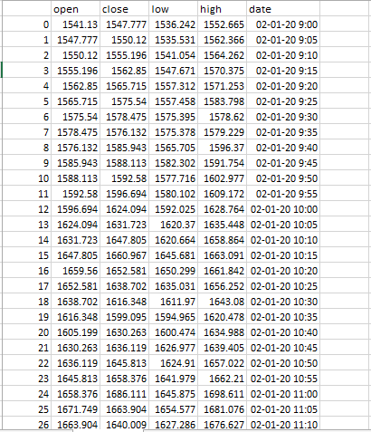

First we make graph of the above data and then we compare the given testdata graph with the all available labelled graphs from the database. It will find similarity with all 5 different patterns and label the test graph generated from above data with the help of similarity.

OUTPUT :-

C:\Users\jenil\OneDrive\Desktop\Capture (1).PNG